EMPLOYEE RAISE ISSUE – RECORD PRODUCER & SERVICE PORTAL INTEGRATION
PHASE 2: Creating a Custom Table and Fields

1. Introduction
This phase creates the backend data structure used to store employee-raised issues. The custom table contains fields for requester information, issue classification, description, state, priority, and assignment.

2. Objective
To create the Employee Raise Issue table and configure all required fields.

3. Creating the Custom Table
1. Navigate to All → System Definition → Tables.
2. Click New.
3. Set Label to Employee Raise Issue.
4. Allow the Name to auto-populate.
5. Under Controls, enable Auto number.
6. Save the table.
7. Under Related Links, select Show Form.
8. Open the context menu and select Configure → Form Design.
9. Create and arrange the required fields.
Employee Raise Issue table creation form
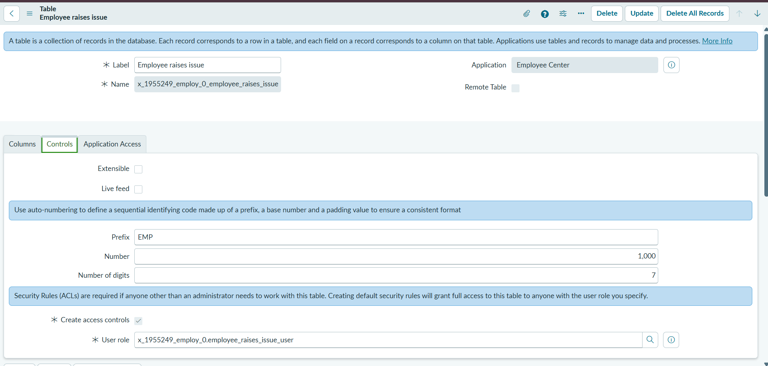

4. Field Configuration
Field Label | Type | Notes
Number | Auto-Number | Automatically generated request number
Requester | Reference | sys_user table
Category | Choice | Network, Hardware, Software, Access
Subcategory | Choice | VPN, Laptop, Server, Forgot password
Short description | String | Issue summary
State | Choice | New, In progress, Resolved, Closed
Priority | Choice | Critical, High, Medium, Low
Assignment Group | Reference | sys_user_group table
Employee Raise Issue form showing the configured fields
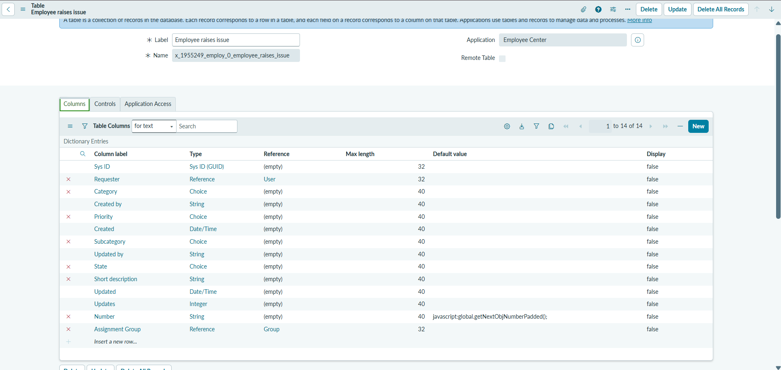
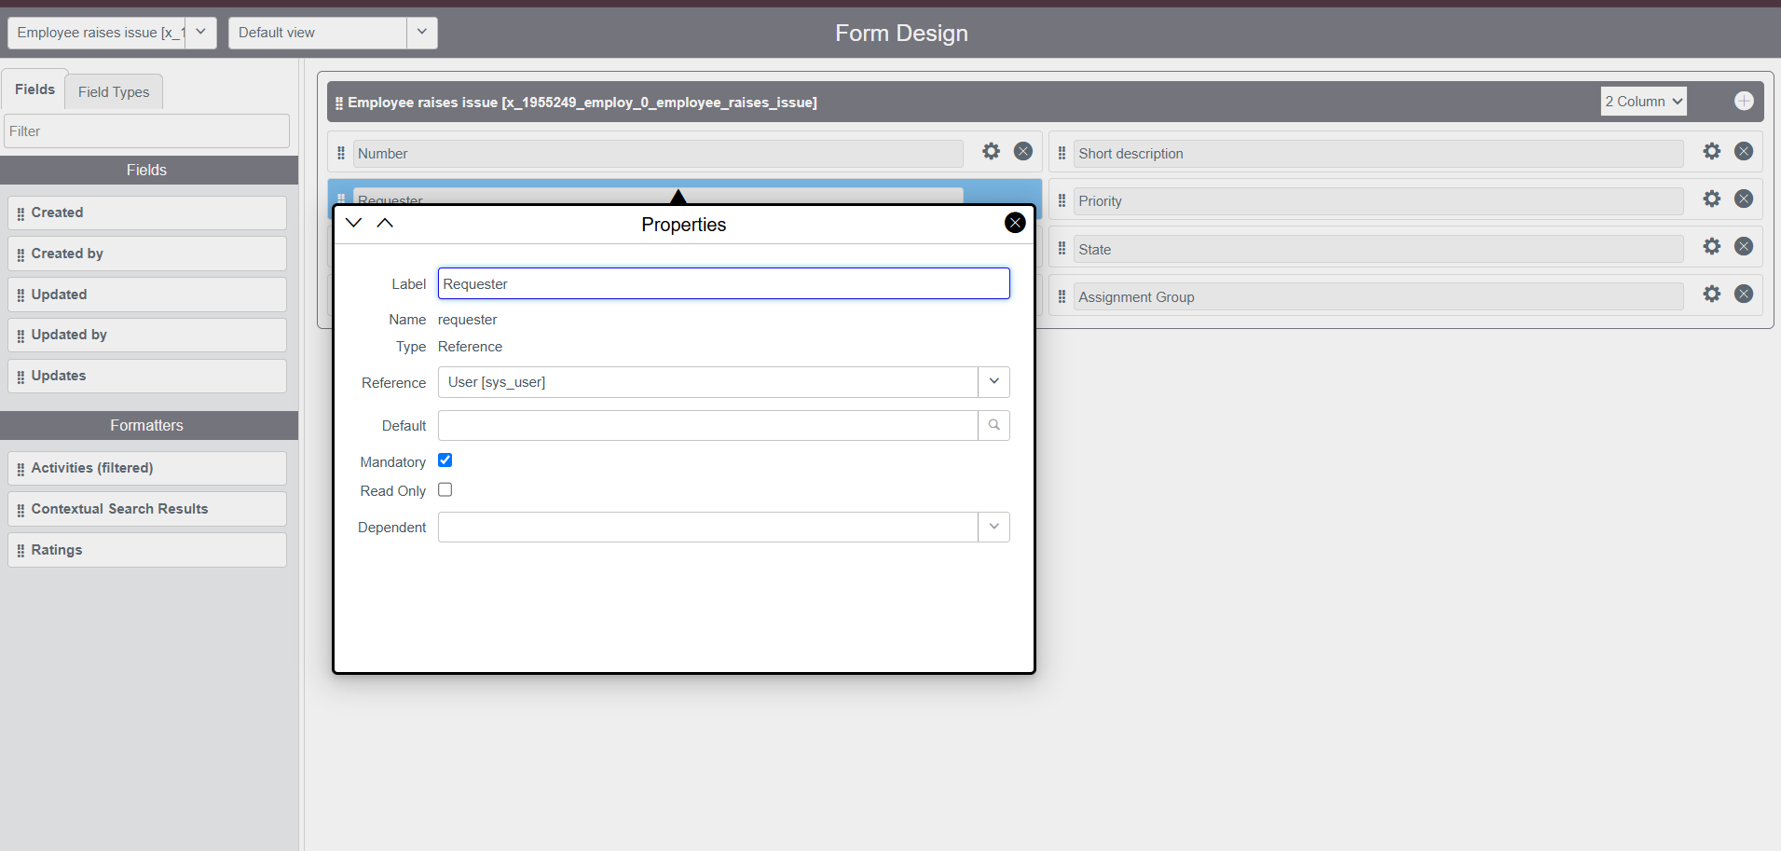
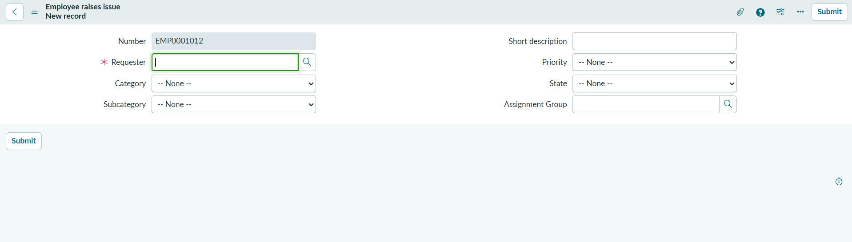

5. Result
The custom Employee Raise Issue table was created successfully and is ready to store structured issue records.

